Supplementary Material
Figure S1: Electropherograms of AMEL-Y null male with off ladder allele variant 7 at DYD438 (SQ 7, 14, 16 and 17).

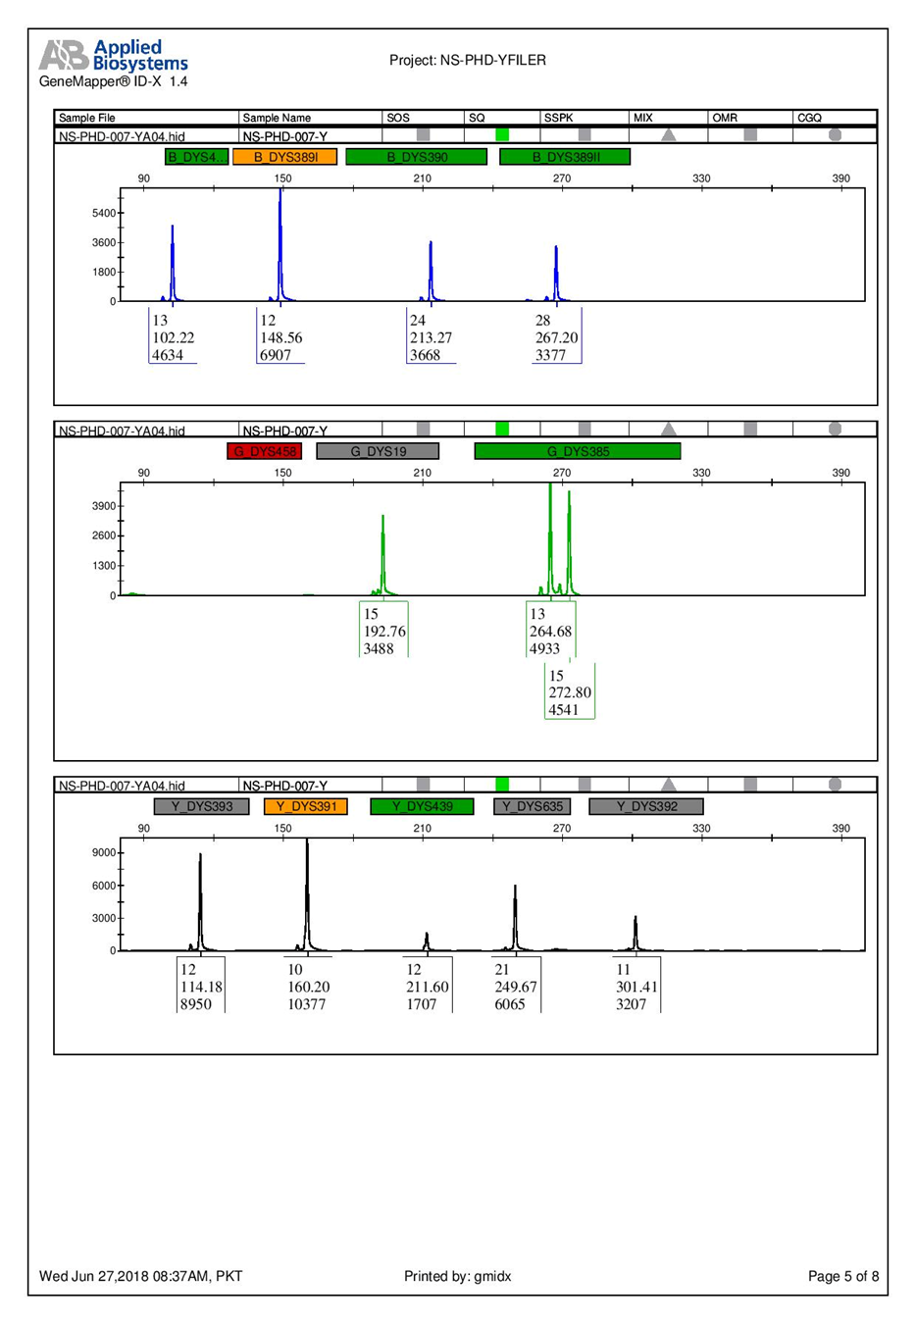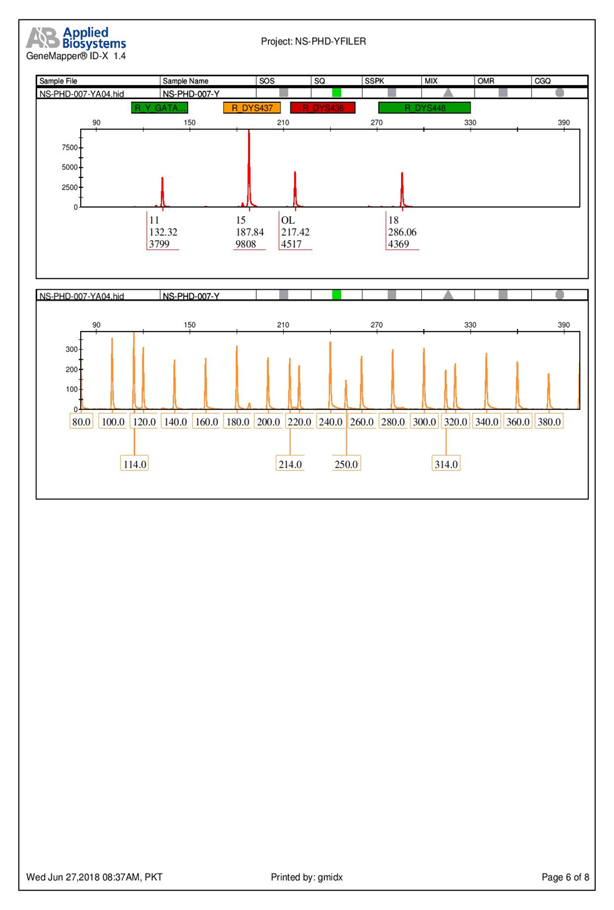
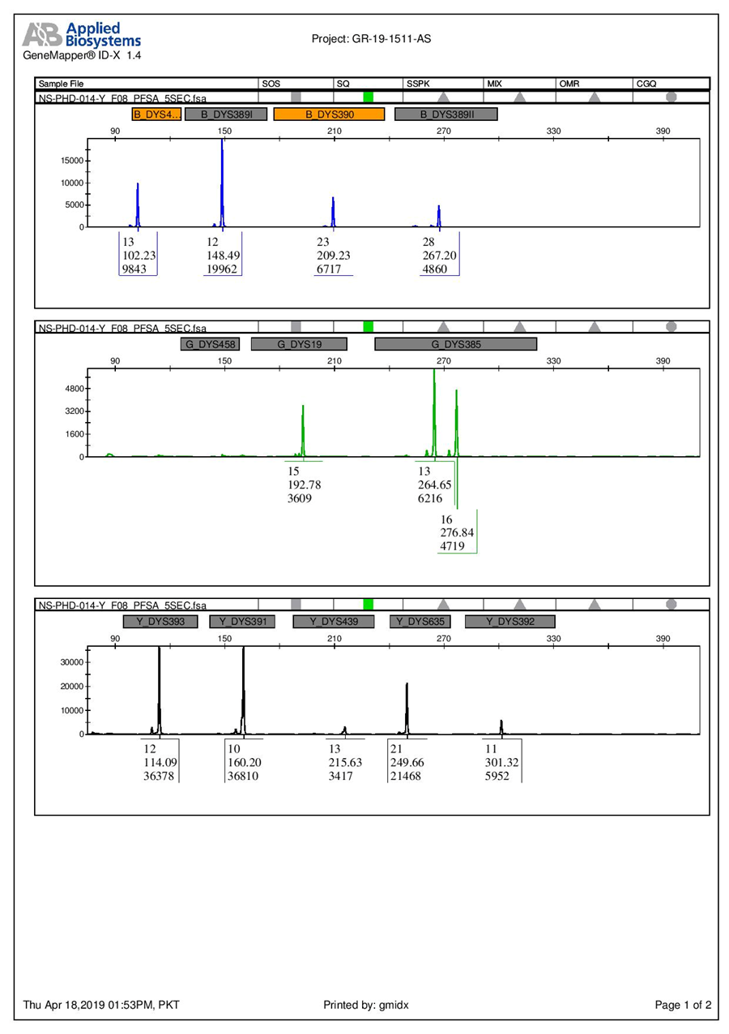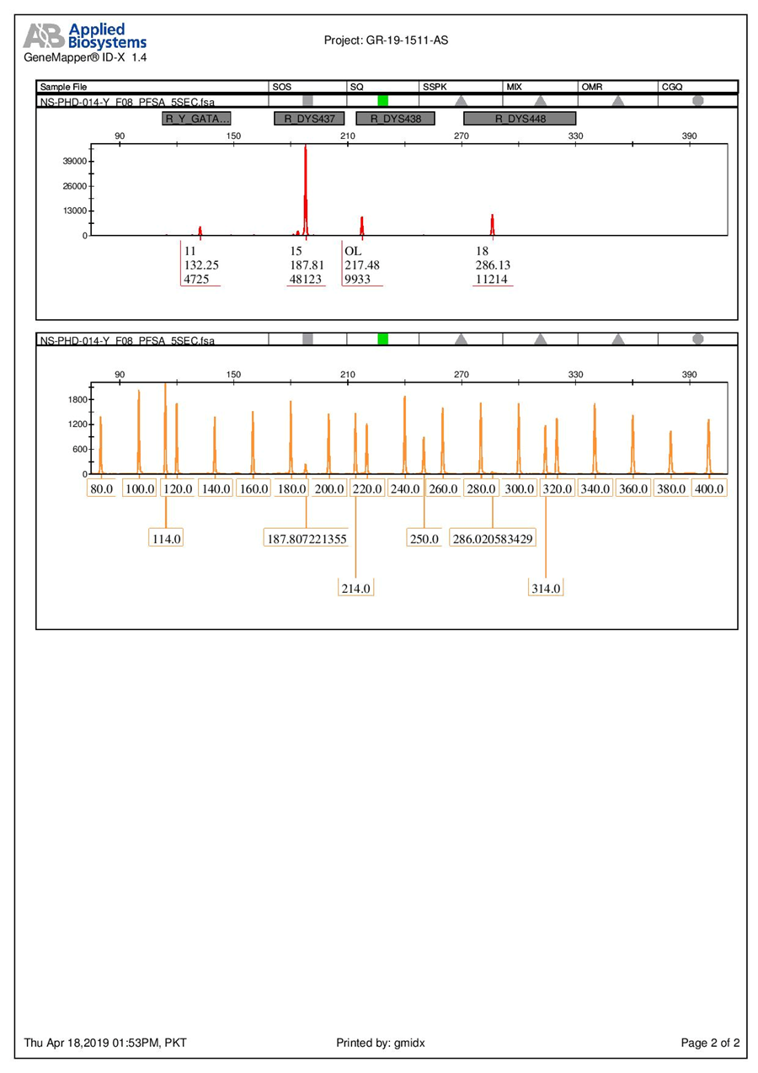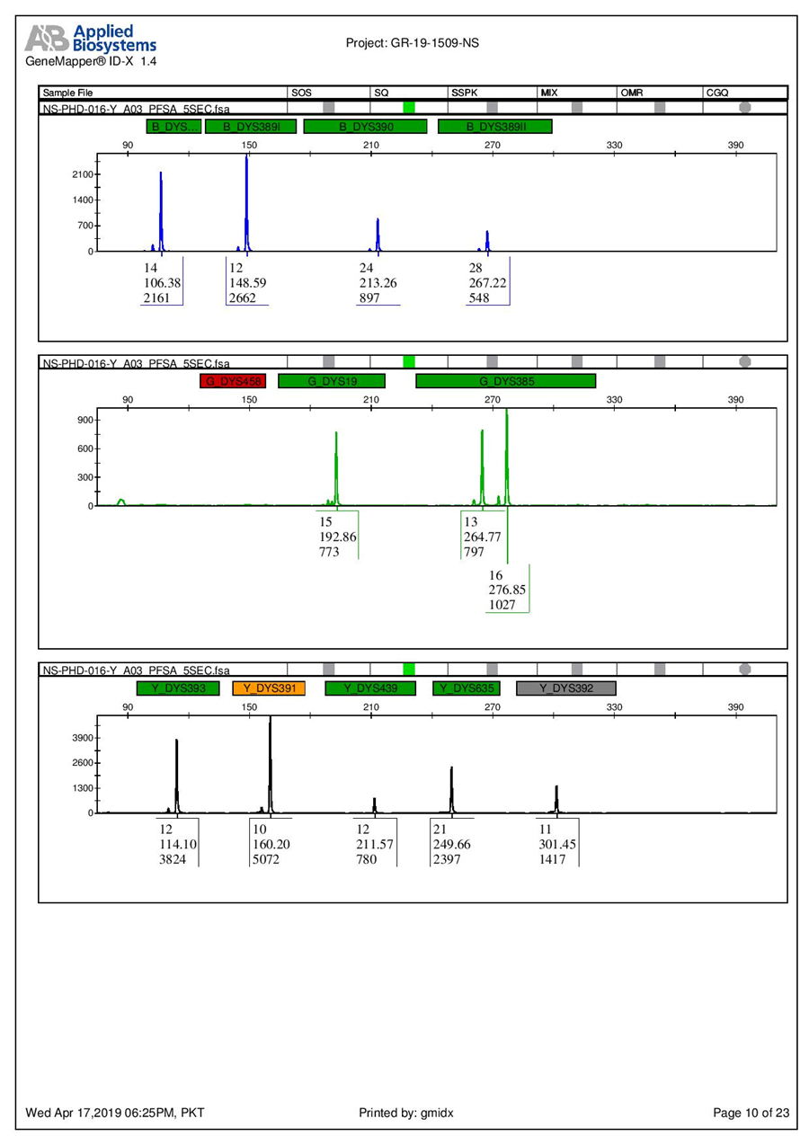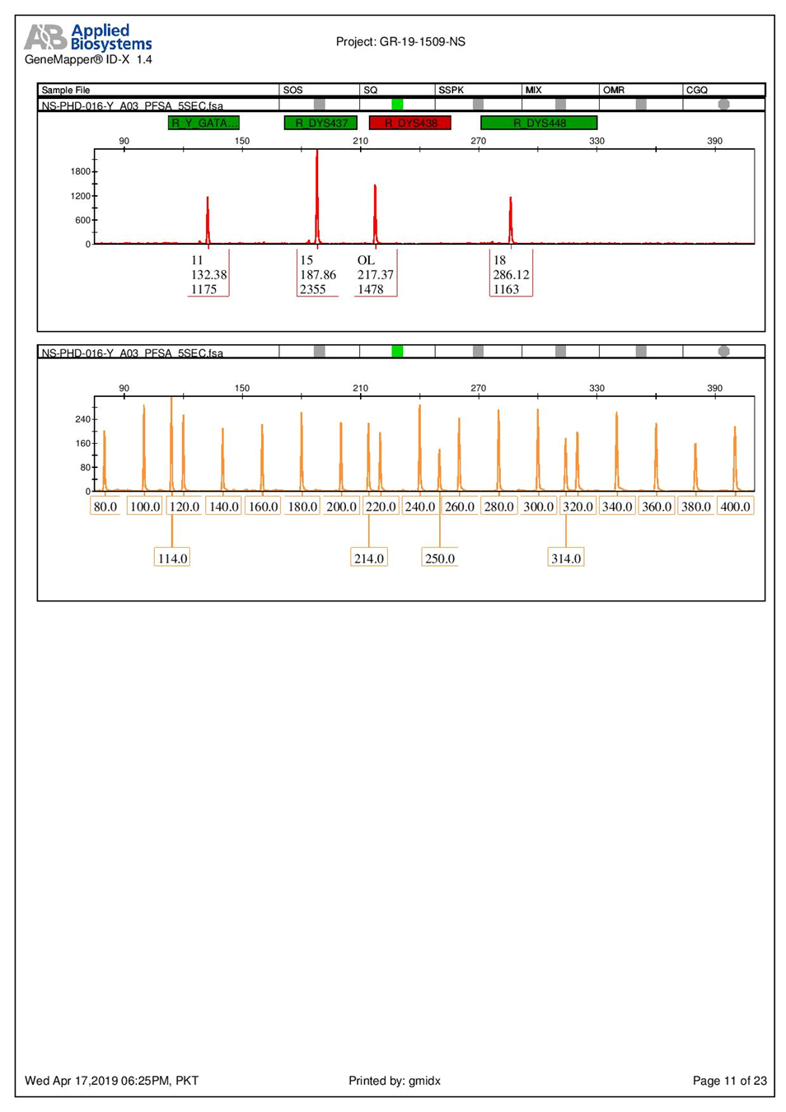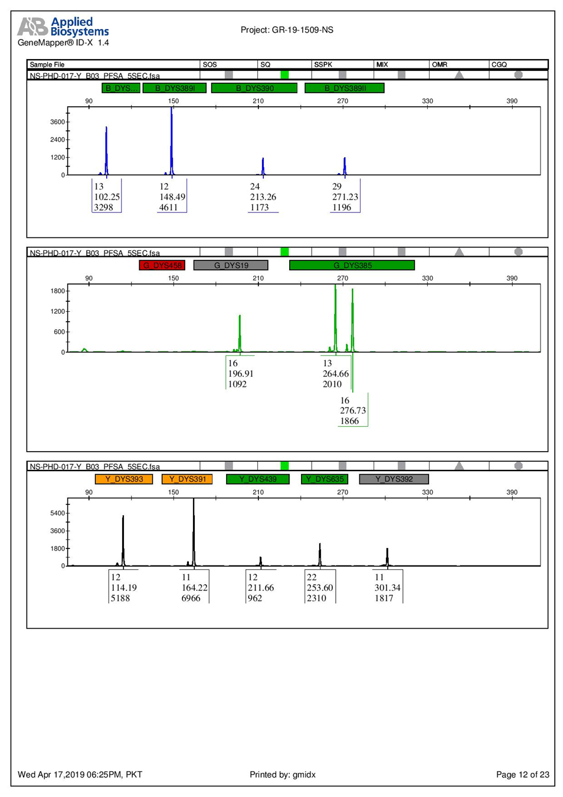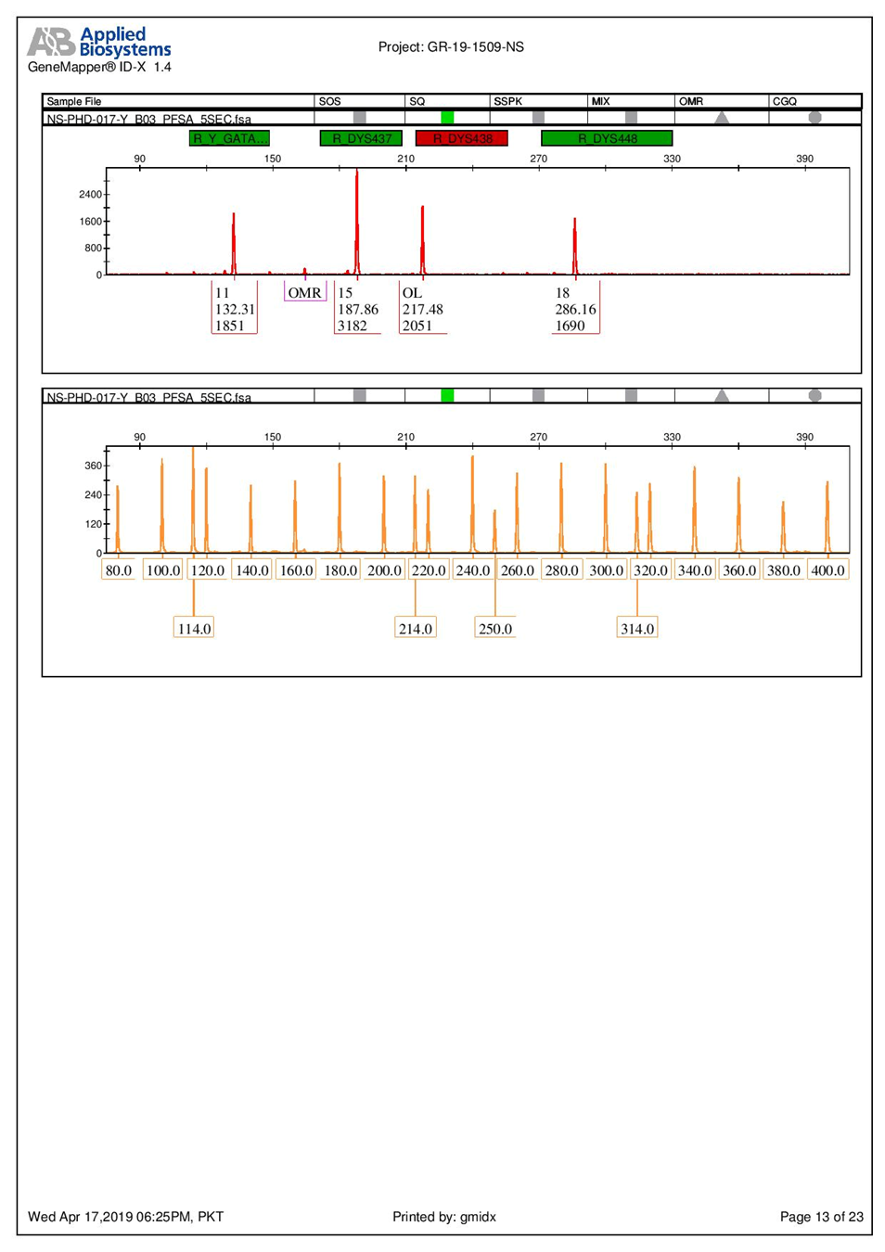

Table S1: Haplo groups of AMELY null Pakistani Males determined through web based software Nevgen Y-DNA haplogroup predictor
Sample No. | Halpo Group | Clade | Subclade(S) | Probability %age | Unsupported subclade
8 | R | R1a | - | 100 | -
1 | J | J2b2a | M241 | 99.7 | -
13 |  | J2b2a | M241 | 99.2 | -
15 |  | J2b2a | M241 | 99.2 | -
2 |  | J2b2a | M241 | 98.6 | -
18 |  | J2b2a | M241 | 98.2 | -
6 |  | J2b2a | PH1648  M241 | 96.2  3.8 | -
12 |  | J2b2a | M241 | 87.14 | 9%
7 |  | J2b2a | M241 | 65.3 | 34.6
14 |  | J2b2a | M241 | 65.3 | 34.6
16 |  | J2b2a | M241 | 65.3 | 34.6
17 |  | J2b2a | M241 | 65.3 | 34.6
3 |  | J2b2a | M241  PH1648 | 53.2  43.8 | -
4 |  | J2b2a | M241  PH1648 | 53.2  43.8 | -
5 |  | J2b2a | M241  PH1648 | 53.2  43.8 | -
9 |  | J2b2a | M241  PH1648 | 53.2  43.8 | -
10 |  | J2b2a | M241  PH1648 | 53.2  43.8 | -
11 |  | J2b2a | M241  PH1648 | 53.2  43.8 | -

Table S2: Maximum number of mutations at each character studies in haplotypes of AMEL-Y null Pakistani Males. Two characters are appended to the locus name (e.g. " DYS389II ") to distinguish between repeat-numbers (e.g. "aa"=27 repeats, "ab"=28 repeats)

No. of Mutations | Y STR Locus
5 | DYS389IIab
4 | DYS19ab
3 | DYS635aa , DYS385Bad
2 | DYS19aa , DYS389Iaa , DYS389IIaa , DYS439ab ,  DYS385Bab , DYS385Bac , DYS385Aab , DYS385Aac , DYS635ab
1 | DYS439ac , DYS448aa , DYS438aa , DYS438ab ,  DYS456aa , DYS456ab , DYS390ab , DYS389IIac ,  DYS385Aaa , DYS385Baa , DYS393aa , DYS391aa,  DYS439aa , DYSH4aa , DYS437aa , DYS438ac ,  DYS438ad , DYS438ae , DYS448ab , DYS390aa

